This is a Precision Packed Tandem Bicycle
This is what it looks like assembled
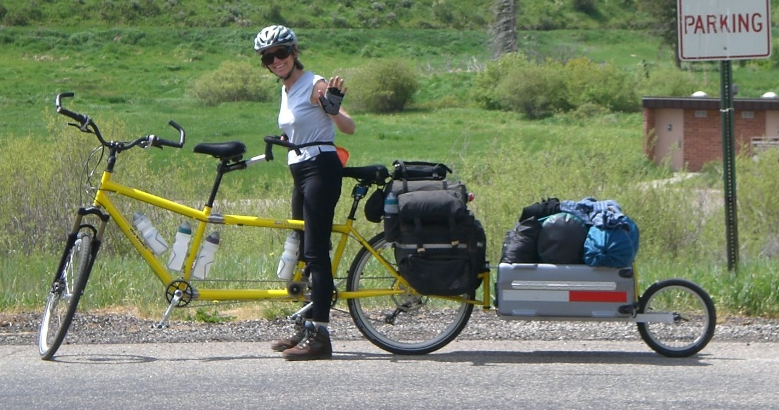

This is Bicycle Case 2 of 2 (Bicycle Components ONLY)
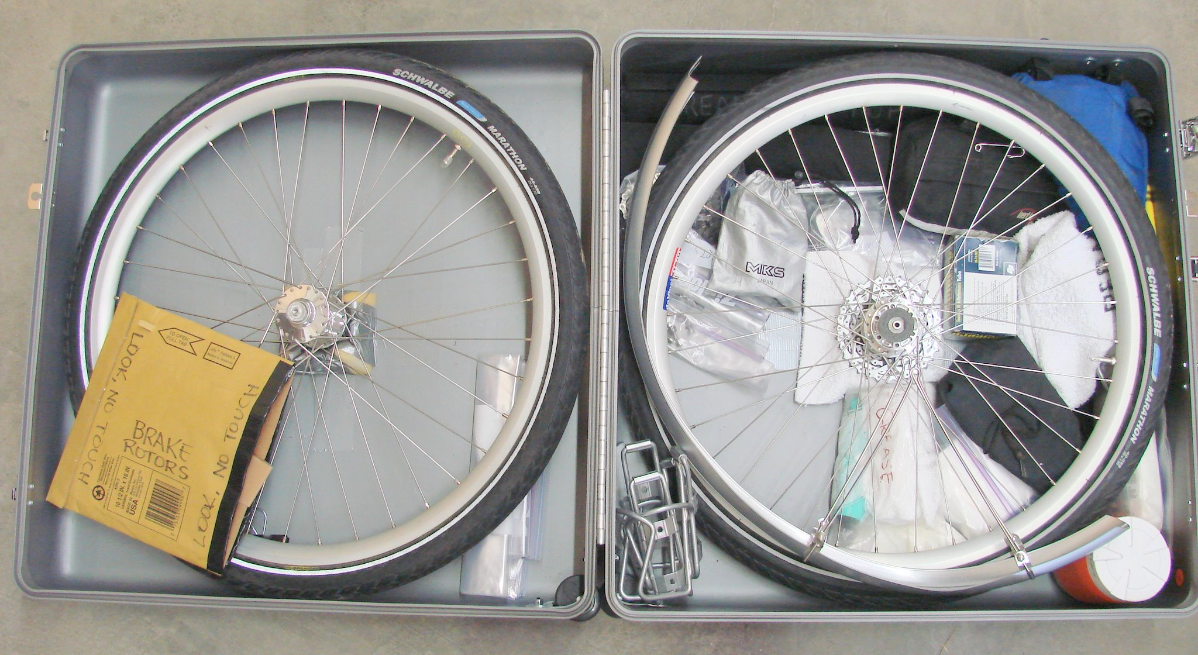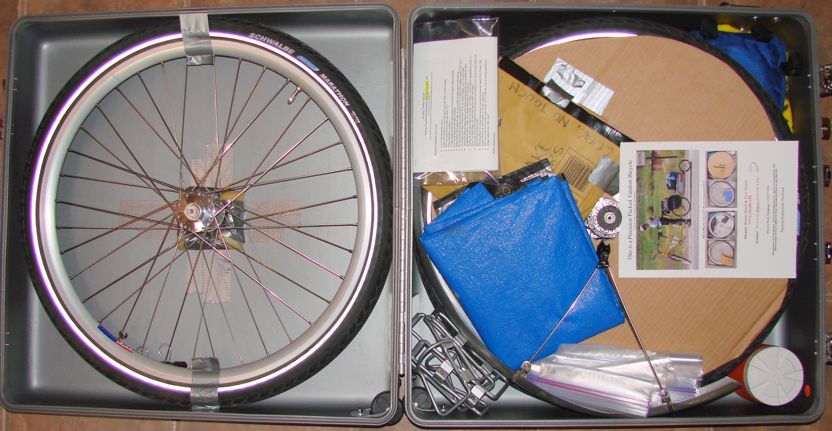

Owners: Dennis Struck & Terry Struck
In USA: 1. 719. 439. 2766
In Europe: UK 44.792.44.745.19

Problem? We're in the Airport, please Call or Page.

Lost Contact? Call our Work Telephone: 1.719.577.9090

Manufacturer: da Vinci Designs, 2145 South Platte River Dr., Denver, Colorado 80223, USA
USA & Canada Toll Free 1 (800) 873-3214. International Phone 01-303-936-1241

Packing Instructions: Enclosed

